THIS FORM IS TO BE COMPLETED BY A HEALTHCARE PROFESSIONAL. Families Can self refer but a Medical Professional must complete the relevant sections.
Is this a referral for end of life support? |  |  |  |  | To avoid delay please contact the appropriate hospice by telephone before sending through the Referral Form. These contacts can be made 24/7 and the telephone numbers can be found on the last page of this form.
 | Yes |  | No

Child’s details
Surname |  | Forename(s) |  |  | Known as
Date of birth |  | or expected date of delivery if not born yet |  |  | NHS number

Gender |  |  |  | Home Address
Religion
Main language(s)
Interpreter required | Yes | No |  | Post Code

Telephone |  |  | Email address

Does the child have a Child Protection Plan? | Yes |  |  | If yes which authority?
 | No

Ethnic Groups
White |  |  | Mixed / Multiple Ethnic Groups |  |  | Asian / Asian British
English / Welsh / Scottish / Northern Irish / British |  |  | White and Black Caribbean |  |  | Indian
Irish |  |  | White and Black African |  |  | Pakistani
Gypsy or Irish Traveller |  |  | White and Asian |  |  | Bangladeshi
Any other white background * |  |  | Any other mixed / multiple ethnic background * |  |  | Chinese
Black / African / Caribbean / Black British |  |  | Other Ethnic Groups |  |  | Any other Asian background *
African |  |  | Arab |  |  | *Please specify if using these categories
Caribbean |  |  | Any other ethnic group *
Any other Black/ African / Caribbean background *

Current family details
Carer 1 |  |  |  |  |  |  |  |  |  |  |  | Carer 2
Name |  |  |  |  |  |  | Same address? |  | Yes |  |  | Name |  |  |  |  |  | Same address? |  | Yes
 |  |  |  |  |  |  |  |  | No |  |  |  |  |  |  |  |  |  |  | No
Address  If different |  |  |  |  |  |  |  |  |  |  |  | Address  If different
Telephone |  |  |  |  |  | Email |  |  |  |  |  | Telephone |  |  |  |  |  | Email
Gender | Male |  |  |  | Relationship to child |  |  |  |  |  |  | Gender | Male |  |  |  | Relationship to child
 | Female |  |  |  | Do they have a disability |  |  |  |  |  |  |  | Female |  |  |  | Do they have a disability
 | Transgender |  |  |  | Ethnic group |  |  |  |  |  |  |  | Transgender |  |  |  | Ethnic group
 | Not known |  |  |  | Religion |  |  |  |  |  |  |  | Not known |  |  |  | Religion
Main language(s) |  |  |  |  |  |  |  |  |  |  |  | Main language(s)
Interpreter required |  |  |  |  |  |  |  |  | Yes |  |  | Interpreter required |  |  |  |  |  |  |  | Yes
 |  |  |  |  |  |  |  |  | No |  |  |  |  |  |  |  |  |  |  | No
Do they read English? |  |  |  |  |  |  |  |  | Yes |  |  | Do they read English? |  |  |  |  |  |  |  | Yes
 |  |  |  |  |  |  |  |  | No |  |  |  |  |  |  |  |  |  |  | No
If not, how do they communicate? |  |  |  |  |  |  |  |  |  |  |  | If not, how do they communicate?

Do they have parental responsibility (PR)? |  |  | Yes |  |  | Do they have parental responsibility |  |  | Yes
 |  |  | No |  |  |  |  |  | No
If no, who has PR? |  |  |  |  |  | If no, who has PR?
What are their contact details |  |  |  |  |  | What are their contact details
Letters to be address to |  |  |  |  |  | Letters to be address to

Julia’s House supports children with palliative care needs.

Acceptance Criteria (This section must be completed by the Child’s Consultant or Doctor)
Julia’s House primary criterion is that the child has a life limiting or life threatening condition that is associated with the risk of death and that this has been discussed with family. A child must be under 18 years old at the time of the referral and live within Dorset or Wiltshire. Antenatal referrals are also accepted.

What is the Primary diagnosis?
Date of Diagnosis
TFSL Category (please see guidance in table below)

TFSL  Category 1 | Life-threatening conditions for which curative treatment may be feasible but can fail.  Access to palliative care services may be necessary when treatment fails or during an acute crisis, irrespective of the duration of threat to life. On reaching long-term remission or  Following successful curative treatment there is no longer a need for palliative care services.  Examples: Cancer, irreversible organ failures of heart, liver, kidney.
TFSL  Category 2 | Conditions where premature death is inevitable.  There may be long periods of intensive treatment aimed at prolonging life and allowing participation in normal activities.  Examples: Cystic fibrosis, Duchenne muscular dystrophy.
TFSL  Category 3 | Progressive conditions without curative treatment options.  Treatment is exclusively palliative and may commonly extend over many years.  Examples: Batten disease, Mucopolysaccharidoses, Rett syndrome. Undiagnosed neuromuscular degenerative conditions,
TFSL  Category 4 | Irreversible but non-progressive conditions causing severe disability, leading to Susceptibility to health complications and likelihood of premature death.  Examples: severe cerebral palsy, multiple disabilities such as following brain or spinal cord injury, complex health care needs, high risk of an unpredictable life-threatening event or episode.

In relation to the categories above which of the secondary criteria below has informed your decision to refer?
Please complete this section with as much information as available, failure to do so will result in a delay of this child and family accessing services.
Cancer  (Cat 1) | Do they have a recognised palliative care need or poor prognosis?
 | Have they relapsed with refractory or recurrent disease?
System Failure  (Cat 1)  Any system failure leading to a life threatening condition for example: | Organ failure awaiting transplant?
 | Severe gut failure requiring total parenteral nutrition?
 | Non-curative or unstable cardiac condition awaiting surgery?
 | Organ failure awaiting transplant?
Ventilation  (Cat 1) | Do they require an artificial airway?
 | Do they require Long term Ventilation?
Cystic Fibrosis  (Cat 2) | Patients with Severe Cystic Fibrosis requiring frequent antibiotics, hospital admissions or complications associated with the disease.
Rett Syndrome  (Cat 3) | DO THEY HAVE 3 OF THE FOLLOWING
 | A diagnosis of Classic, rather than Non-classic, Rett
 | Severely reduced or increased tone
 | Inability to have walked
 | Frequent epileptic fits (other than vacant episodes)
 | Blackouts associated with respiratory disturbance
 | Severe feeding difficulties
 | Inadequate weight gain
Neuro-disability  (Cat 4) | Do they have an inherited or metabolic condition causing severe neuro-disability?
 | OR
 | Do they have a severe acquired neuro-disability?
 | AND HAVE 2 OF THE FOLLOWING
 | A vulnerable airway eg. Stridor, apnoea, requiring airway repositioning or jaw thrust, unsafe swallow with a high aspiration risk or requiring frequent suctioning to maintain airway
 | Severe Scoliosis compromising respiratory function
 | Multiple Unplanned inpatient hospital admissions per year
 | An ongoing need for oxygen therapy or ventilatory support
 | Gut failure
 | Instability of brainstem function (temperature, circulation or breathing)
 | Severe dystonic episodes requiring comprehensive treatment plan.
 | Change in condition emphasising the life limiting or threatening nature.
 | Complex angalgesia regime to manage uncontrolled pain
 | Poor Seizure control despite optimum treatment
 | Age 0-12 months
Seizures  (Cat 4)  This should not be used for a young person whose epilepsy is part of another underlying condition e.g. Cerebral Palsy | Are seizures life threatening? The risk of SUDEP is not sufficient to meet this criterion
 | Are seizures poorly controlled requiring frequent hospital admission
 | Is the seizure disorder progressive, with or without syndrome diagnosis
 | Are seizures the result of a life limiting condition

How would you assess the child’s phase of illness currently? Please tick accordingly.
Stable |  | Unstable |  | Deteriorating |  | End of Life
- Symptoms are adequately controlled by an established plan of care  and  - Further interventions have been planned |  | - New Problem that was not anticipated  and/or  - A rapid increase in severity of a current issue |  | - Overall Status is declining  And  - Experiences a gradual worsening of existing issues  And/or  - Experience a new but anticipated problem |  | - Care is defined by focus of end phase of condition  - Withdrawal of treatment

Summary of Medical Condition
Please provide supporting evidence by including a recent clinic letter and any medications/protocols relevant to the child. Unfortunately without these documents there will be a delay in being able to process the referral.

Name of Consultant/
Doctor completing form Signature

Siblings (and other household family members)
Relationship  to child | Sibling name | Gender | DOB | DOD | Do they have the same condition (Y/N) | Please specify if language ethnicity or religion are different?

Additional information such as relevant current family circumstances and details of any significant others that help provide care

Professionals involved with the child/young person

General Practitioner
GP Name |  | Telephone
Address |  | Postcode
CCG |  | Email

Consultants please complete for all consultants involved with child/young person
Consultant | Hospital | Telephone number | Email

Other professionals involved please complete for health, education or social care e.g. Social Worker, Health Visitor, CCN, Occupational Therapist or Physiotherapist
Name and Title | Address | Telephone number | Email | Type and frequency of support and service provided

Please identify any other providers you are aware of that are already providing support to the family

Who or what prompted you to make this referral to Julias House?

Referrer
By signing the Referral Form you are confirming this referral has been consented to by the family and the family have been given ‘Your Referral to Julia’s House’ information sheet, which is the last page of this document.

Name |  | Job title  (if relevant)
Role |  | Organisation and Address
Telephone numbers |  | Email
Signature |  | Date

Consent of Family. To be completed by Parent or Legal Guardian with parental responsibility.

I, __________________________ , the Parent/Legal Guardian of _________________________ (child)
(print name) (print name of child)

am aware of the contents of this form and consent to this referral being made to Julia’s House Children’s Respite Service. I also give consent for the Julia’s House Nursing Team to request information and liaise with any of the professionals listed within this form that are involved in the care of the above named person.
Signature: Date:
Child’s signature if appropriate: Date:

Please return to: Julia’s House Children’s Hospice
Address | Telephone | Fax | Email
Julia’s House in Dorset
135 Springdale Road, Corfe Mullen, Broadstone, BH18 9BP
Julia’s House in Wiltshire
Bath Road, Devizes, SN10 2AT
NHS NET email account |  |  | dorset.juliashouse@nhs.net  wiltshire.juliashouse@nhs.net

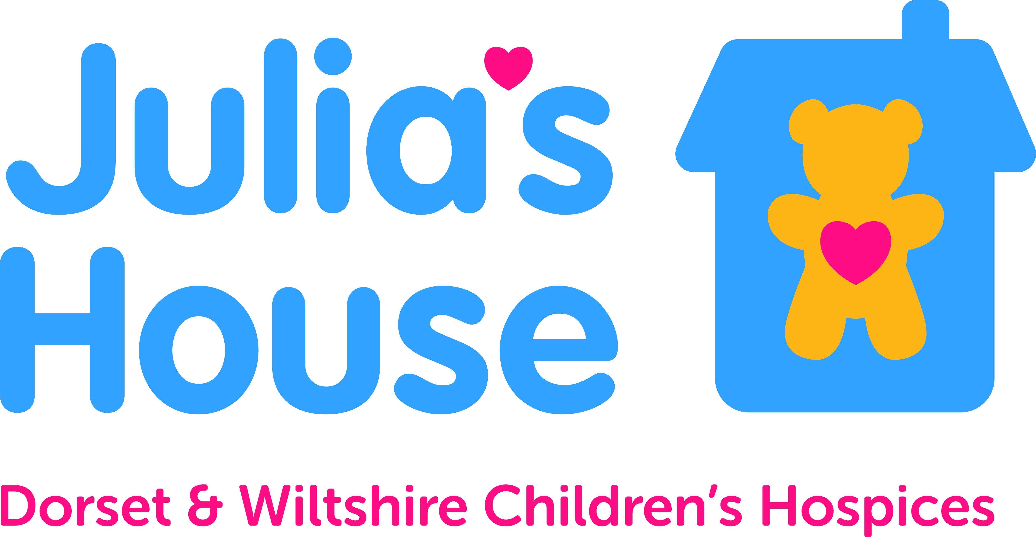
Referrer please give this page to the family

Your referral to Julia’s House

Information about a referral to Julia’s House
Your child has been referred to Julia’s House. We provide a range of services to support children and their families across Dorset and Wiltshire.

What happens next?
All referrals are given careful consideration as soon as they arrive at Julia’s House. If the referral is for emergency or end of life care we will respond quickly and contact you to arrange a meeting. All other referrals will be considered at our next panel meeting which meets each month. If we have the information we need to make a decision of acceptance, we will allocate a Lead Nurse who will contact you to arrange a home visit to start the Assessment process.

In order to process your referral we may need to contact you and/or medical professionals involved with your child such as consultants, your GP etc. to seek further information. It may therefore take longer before a decision is made.

If my child is accepted?
If your child meets our criteria they will be accepted, we will contact you to inform you of our decision. We will also allocate a named nurse who will be involved in the assessment process and be your main point of contact.

You and your family will be involved throughout the Assessment process to assess your needs and identify which of Julia’s House services will help you most. The Assessment will be undertaken within six weeks if we have all the relevant information from medical professionals. Once the services have been agreed we will be able to start to put these in place.
Page 1 of 2
Please note that all children are subject to regular reviews which will involve contacting your medical team for up to date information as well as discussing any changing needs. On an annual basis we will review the referral criteria again to ensure your child continues to be eligible for Julia’s House services. Occasionally the criteria is no longer met, if this is the case a notice period will be served and we will endeavour to support you through this process.

Julia’s House do not support children and family members after 18. We will work with you to facilitate a smooth transition.

What if my child is not accepted?
Sadly we cannot offer support to every child or young person referred to us and have to focus on those children who meet out criteria. If your child is not accepted we may be able to suggest other services you can consider contacting.

You can ask us to reconsider if you think there are factors we have overlooked.

Re- Referrals are welcome at any time should your child’s condition change.

If you have any questions please contact us on;
Page 2 of 2

Julia’s House for Dorset  35 Springdale Road, Corfe Mullen, Broadstone, BH18 9BP  Telephone 01202 389837 | Julia’s House for Wiltshire  Bath Road, Devizes, SN10 2AT  Telephone 01380 562525

